PERCENTAGE CHANGE
Pearson Edexcel - Tuesday 19 May 2020 - Paper 1 (Non-Calculator) Foundation Tier

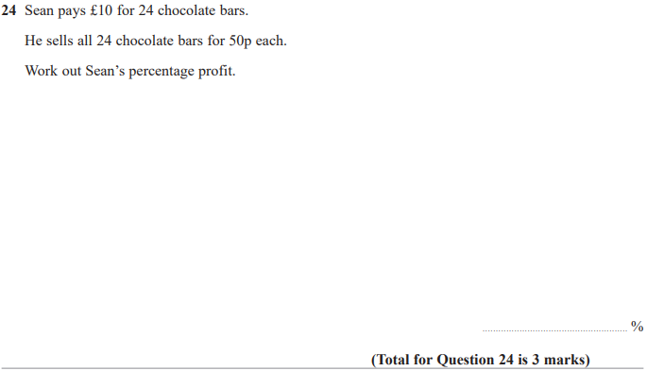

Pearson Edexcel - Thursday 8 November 2018 - Paper 2 (Calculator) Foundation Tier

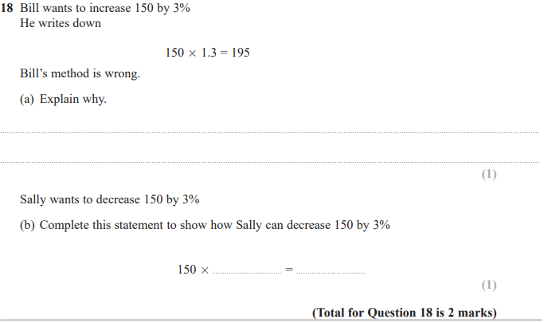
Pearson Edexcel - Monday 12 November 2018 - Paper 3 (Calculator) Foundation Tier

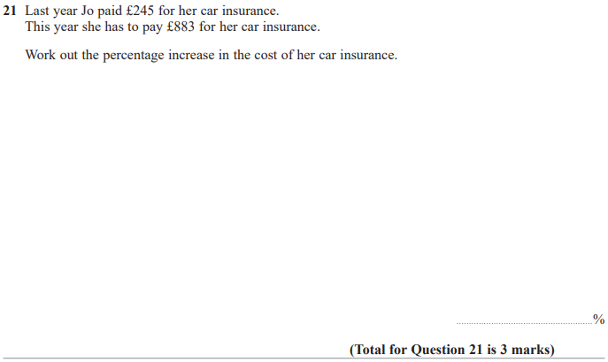
Pearson Edexcel - Thursday 24 May 2018 - Paper 1 (Non-Calculator) Foundation Tier

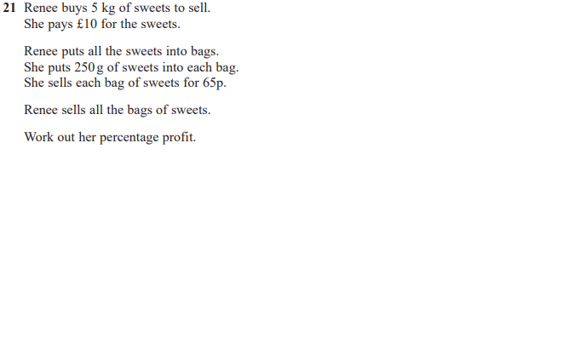

Pearson Edexcel - Thursday 7 June 2018 - Paper 2 (Calculator) Foundation Tier

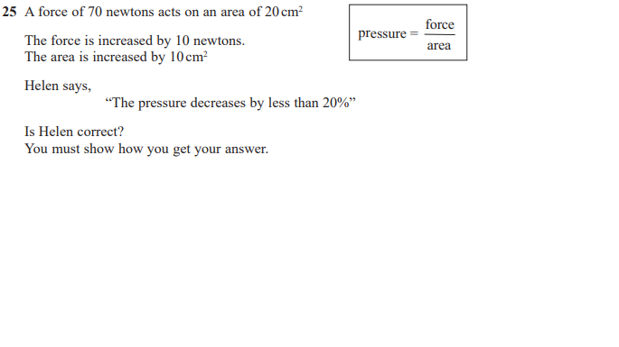

Pearson Edexcel - Thursday 2 November 2017 - Paper 1 (Non-Calculator) Foundation Tier

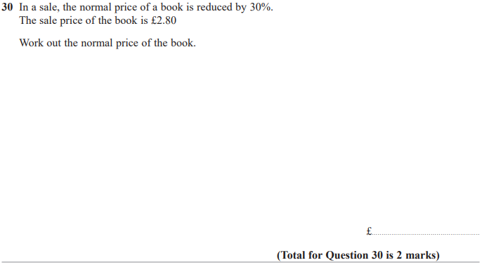

Pearson Edexcel - Monday 6 November 2017 - Paper 2 (Calculator) Foundation Tier

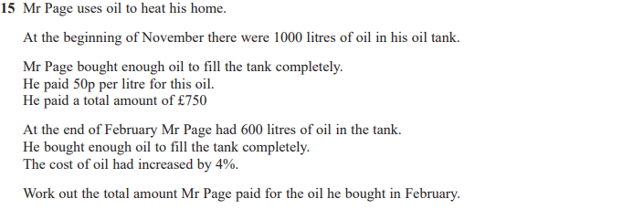

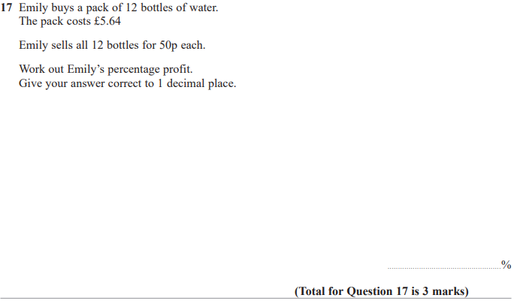

Pearson Edexcel – Specimen 2 - Paper 1 (Non-Calculator) Foundation Tier

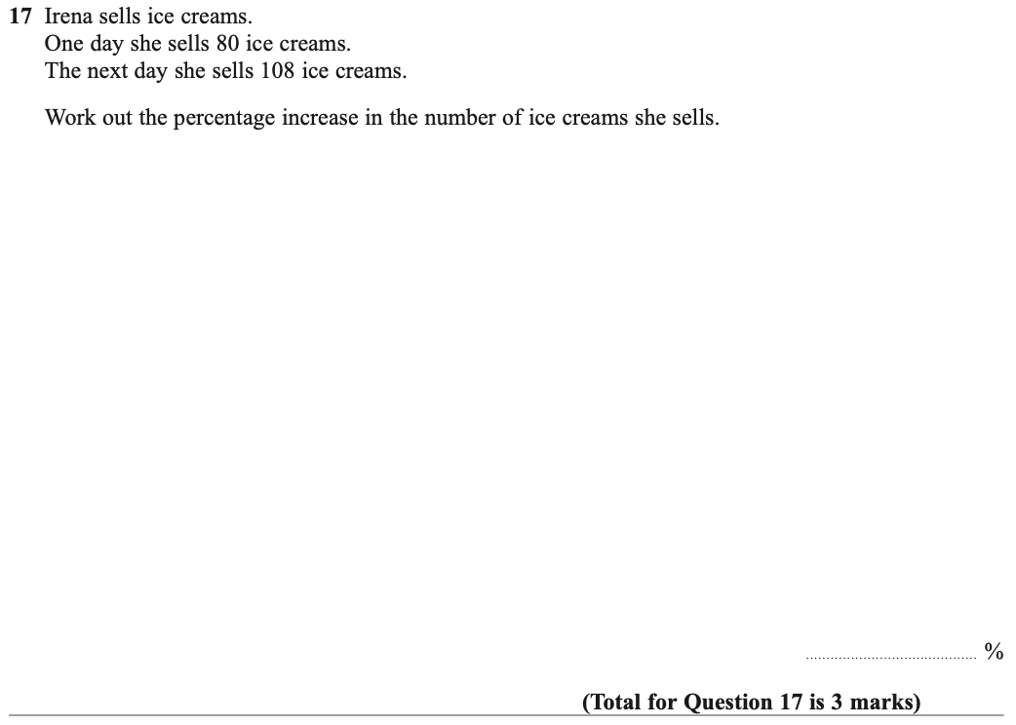

OCR – Tuesday 03 November 2020- Morning - Paper 1 (Calculator) Foundation Tier
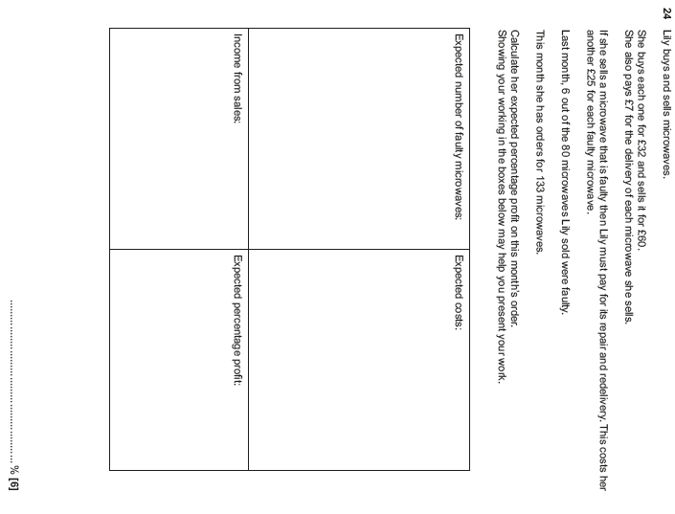

OCR Thursday 05 November 2020- Morning (Non-Calculator) Foundation Tier
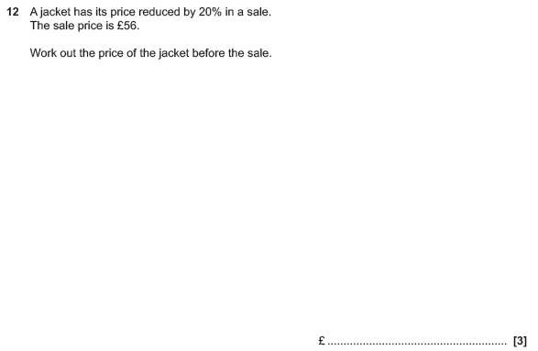

OCR Thursday 07 November 2019- Morning (Non-Calculator) Foundation Tier
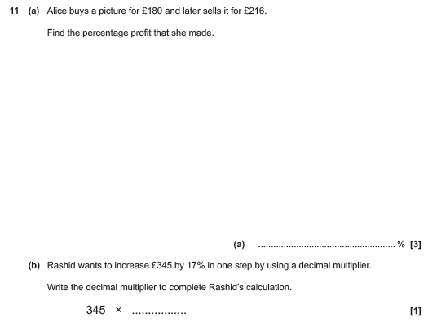

OCR Monday 11 November 2019 – Afternoon (Calculator) Foundation Tier

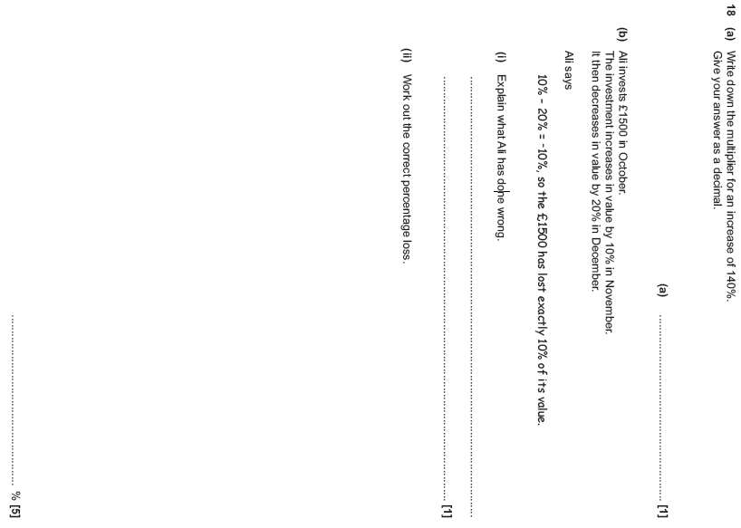

OCR Monday 11 November 2019 – Afternoon (Calculator) Foundation Tier
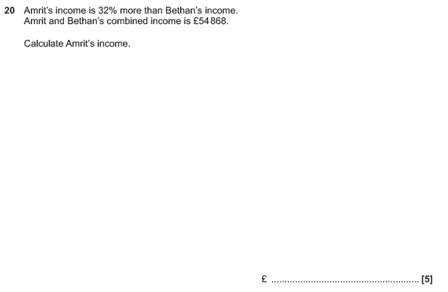

OCR Thursday 6 June 2019 – Morning (Non-Calculator) Foundation Tier
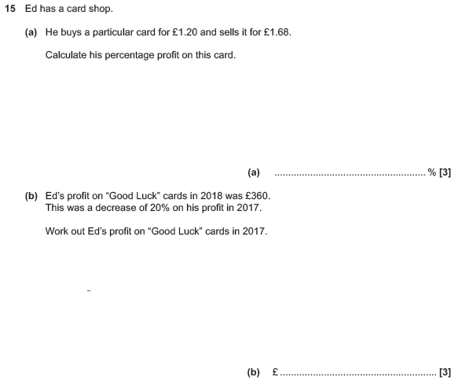

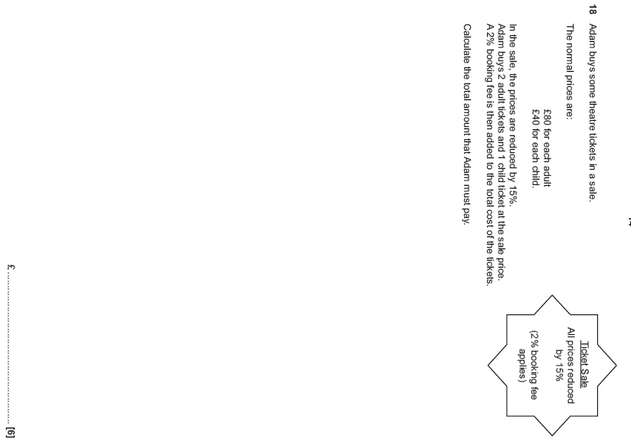

OCR Thursday 8 November 2018 – Morning (Non-Calculator) Foundation Tier
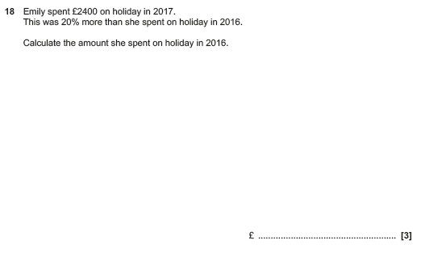

OCR Monday 12 November 2018 – Morning (Calculator) Foundation Tier
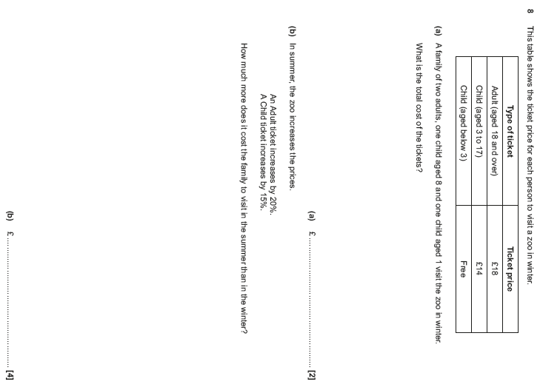

OCR Monday 24 May 2018 – Morning (Calculator) Foundation Tier
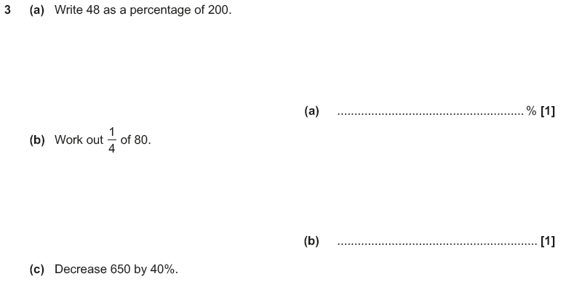

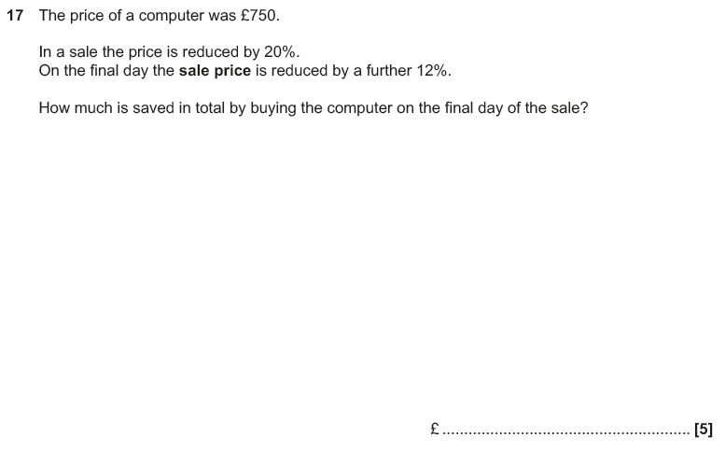

OCR Tuesday 12 June 2018– Morning (Calculator) Foundation Tier
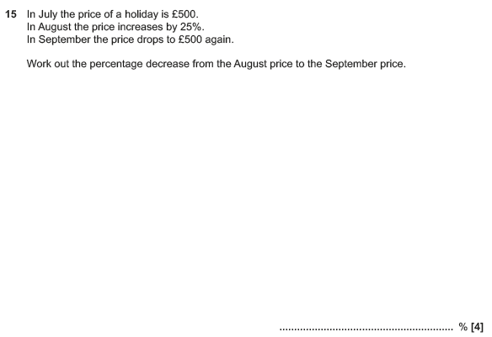

OCR Thursday 2 November 2017– Morning (Calculator) Foundation Tier
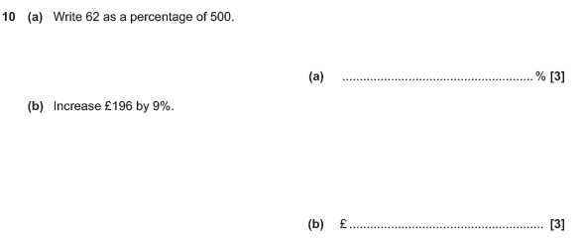

Pearson Edexcel – Sample Papers - Paper 1 (Non-Calculator) Foundation Tier

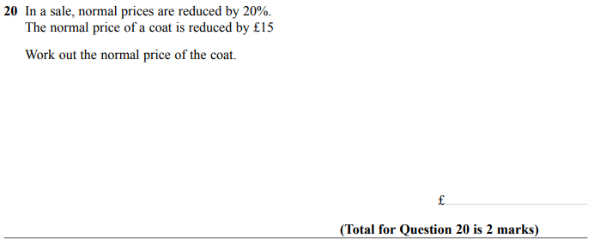
AQA Sample Paper 3– Morning (Calculator) Foundation Tier

